SEMESTER ONE
Papers written by
Australian Maths Software

YEAR 12, UNIT 3

MATHEMATICS APPLICATIONS
REVISION 1
2016

Section Two
(Calculator–assumed)

Name: _________________________________

Teacher: ________________________________

TIME ALLOWED FOR THIS SECTION

Reading time before commencing work: 10 minutes
Working time for section: 100 minutes

MATERIAL REQUIRED / RECOMMENDED FOR THIS SECTION

To be provided by the candidate

Standard items: pens, pencils, pencil sharpener, highlighter, eraser, ruler.

Special items: drawing instruments, templates, notes on up to two unfolded sheet of A4 paper, and up to three calculators approved for use in the WACE examinations.

IMPORTANT NOTE TO CANDIDATES

No other items may be taken into the examination room. It is your responsibility to ensure that you do not have any unauthorised notes or other items of a non–personal nature in the examination room. If you have any unauthorised material with you, hand it to the supervisor before reading any further.

To be provided by the supervisor
Question/answer booklet for Section Two.
Formula sheet retained from Section One.
Structure of this examination

 | Number of questions available | Number of questions to be answered | Working time (minutes) | Marks available | Percentage of exam
Section One  Calculator—free | 7 | 7 | 50 | 52 | 35
Section Two  Calculator—assumed | 10 | 10 | 100 | 98 | 65
Total marks |  |  |  | 150

Instructions to candidates

1. The rules for the conduct of this examination are detailed in the Information Handbook. Sitting this examination implies that you agree to abide by these rules.

2. Write your answers in the Question/Answer booklet.

3. You must be careful to confine your responses to the specific questions asked and to
follow any instructions that are specific to a particular question.

4. Spare pages are provided at the end of this booklet. If you need to use them, indicate
in the original answer space where the answer is continued i.e. give the page number.

5. Show all your working clearly. Your working should be in sufficient detail to allow your answers to be checked readily and for marks to be awarded for reasoning. Incorrect answers given without supporting reasoning cannot be allocated any marks. For any question or part question worth more than two marks, valid working or justification is required to receive full marks. If you repeat an answer to any question, ensure that you cancel the answer you do not wish to have marked.

6. It is recommended that you do not use pencil, except in diagrams.

7. The Formula Sheet is not to be handed in with your Question/Answer booklet.

8. (4 marks)
(a) Consider the following three dimensional model of an icosahedron.
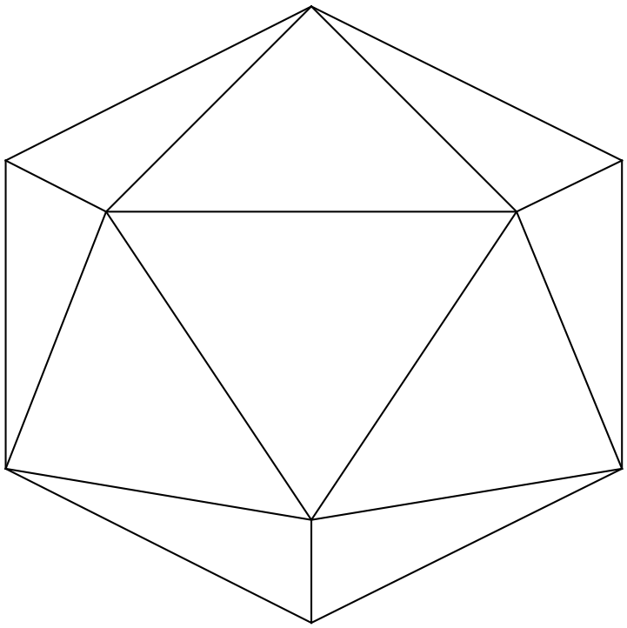
Given V = 12, E = 30 determine the number of faces F where
V = number of faces and E = number of edges. (2)

(b) Select the Schlegel diagram that correponds to the icosahedron from those listed below
stating your reasons.
NB A schlegel diagram is a two dimensional planar graph that corresponds to the
polyhedron. (2)

(A) (B) (C) (D) (E)
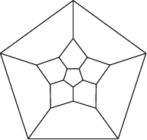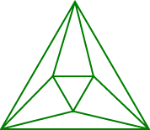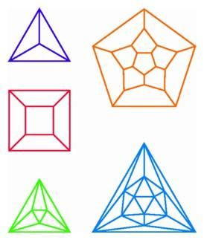

9. (9 marks)

A group of ladies has been knitting warm beanies for Australian overseas army troops.
At the end of the week that Jenny joined the group, they had knitted a total of 40 beanies.
The group planned to knit 12 beanies a week.

(a) Complete the following table. (3)

n | Total number of beanies knitted at end of week n
1 | 40
2
3
4

(b) Determine an expression, in terms of n, for the total number of beanies knitted
n weeks after Jenny joined the group. (2)

(c) How many beanies will they have knitted 18 weeks after Jenny joined the group?
(2)

(d) How many weeks after Jenny joined the group will it have knitted a total of 400 beanies? (2)

10. (8 marks)
A sequence is formed by adding the arithmetic term and the geometric terms of two given
sequences.

Geometric sequence | 10 | 10² | 10³ | 1 0⁴
Arithmetic sequence | 3 | 6 | 9 | 12

Combined sequence: 13, 106, 1 009, 10 012,….
which is derived from 10 + 3, 100 + 6, 1000 + 9, 10 000 + 12
(a) Define the arithmetic and geometric sequences in terms of n. (2+2)

(b) (i) Define the combined sequence in terms of n. (2)

(ii) Determine the 6th term of the combined sequence. (2)

11. (12 marks)

Jack and Jill play a game with a fair dice. A dice is rolled and whoever gets a six first wins the game. Jack is a gentleman and lets Jill roll first.
The chance that Jack wins on his first roll is 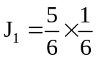 as Jill must not get a six on her roll so has 5 chances out of 6. Jack MUST then get a 6 to win so has one chance out of 6.
The chance that Jack wins on his second roll is 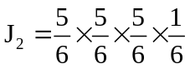 as Jill must not get a six on her roll, nor Jack on his first roll, nor Jill on her second roll, but he must get a six on his second roll.
This can be summarised in the chart below.

Probability that Jack wins on his first roll | 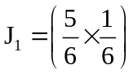 | 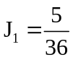
Probability that Jack wins on his second roll | 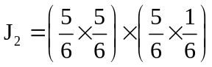 | 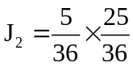
Probability that Jack wins on his third roll | 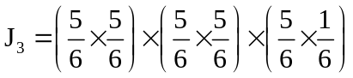 | 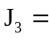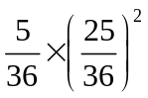

(a) Explain why the sequence 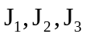 form a geometric sequence. (2)

(b) What are the chances that Jack wins on his fifth roll? (3)

(c) What are the chances that Jill wins on her second roll? (3)

(d) Find an expression that Jack wins on his nth roll. (2)

(e) Given that the probability that Jack wins close to 0.01082, how many times did he have
to roll for him to win? (2)

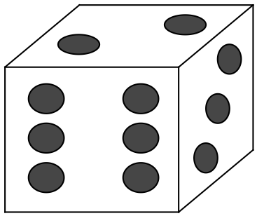
12. (9 marks)

(a) (i) Sketch a Hamiltonian circuit on the cube and list the circuit. (3)

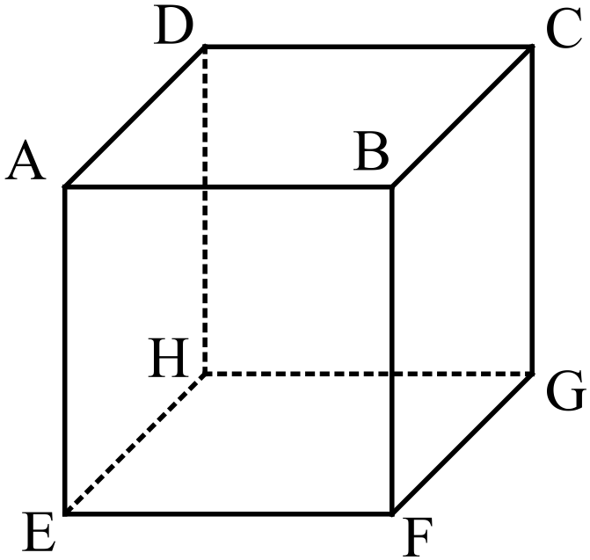

(ii) Explain why the cube does not represent a three dimensional Eulerian graph.
(2)

(b) Andy wants to explore all the roads between 7 cities to determine the best route
for a bicycle race next season.
Andy is currently at city A and wishes to finish back at A.
Is his plan feasible? Explain why and list a possible route. (4)

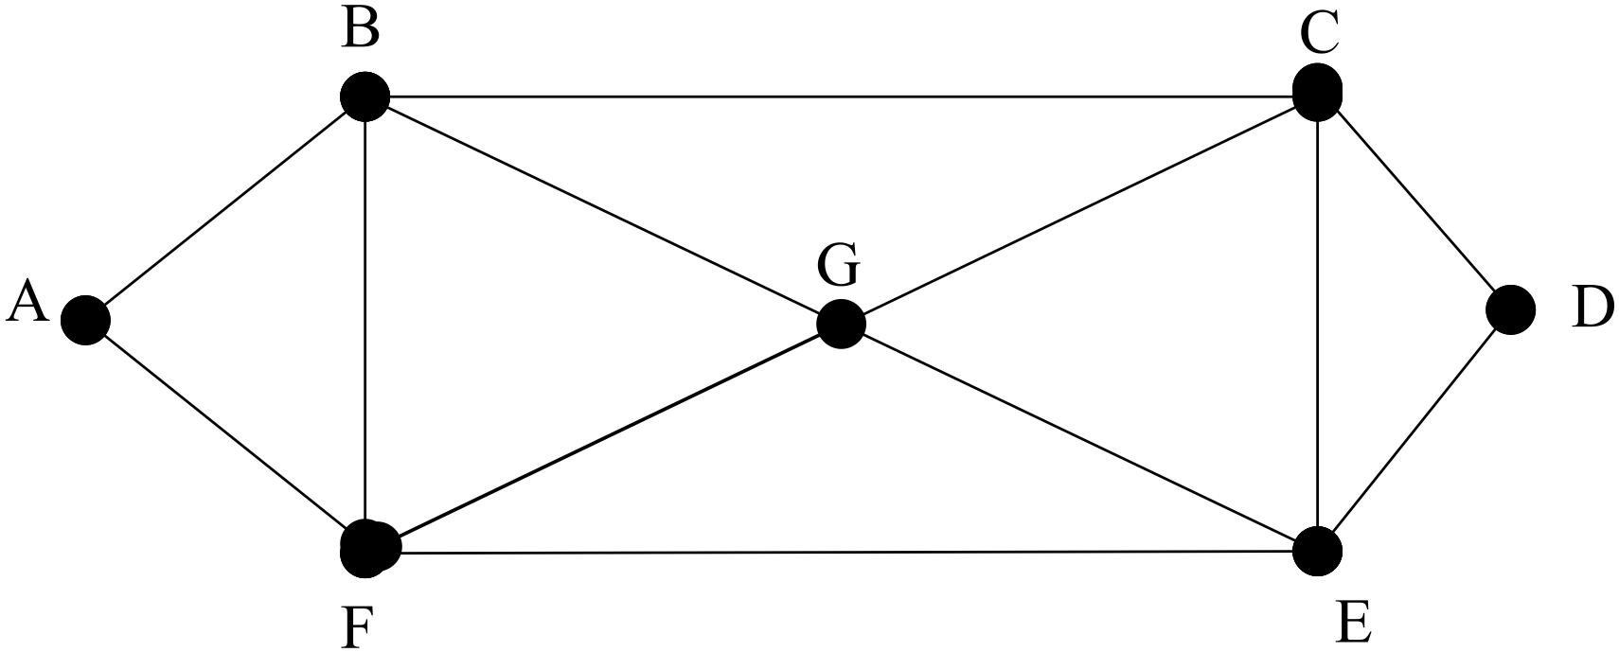


13. (4 marks)

(a) Consider the graph below.

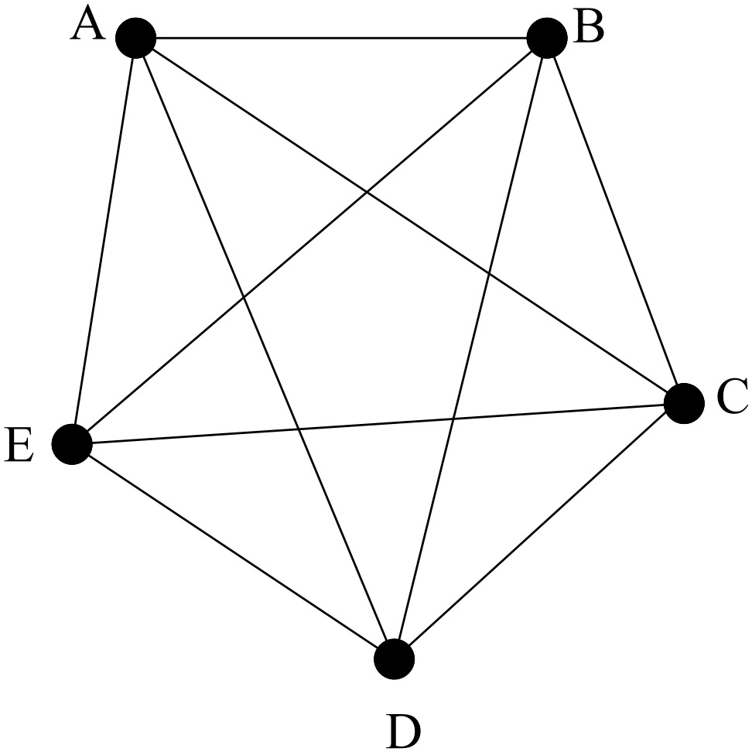

(i) Write down the degree of vertex D. (1)

(ii) Determine the nunber of arcs in the graph. (1)

(b) The graph below can be desribed in several ways. Select two correct descriptions and
give reasons for your selection.

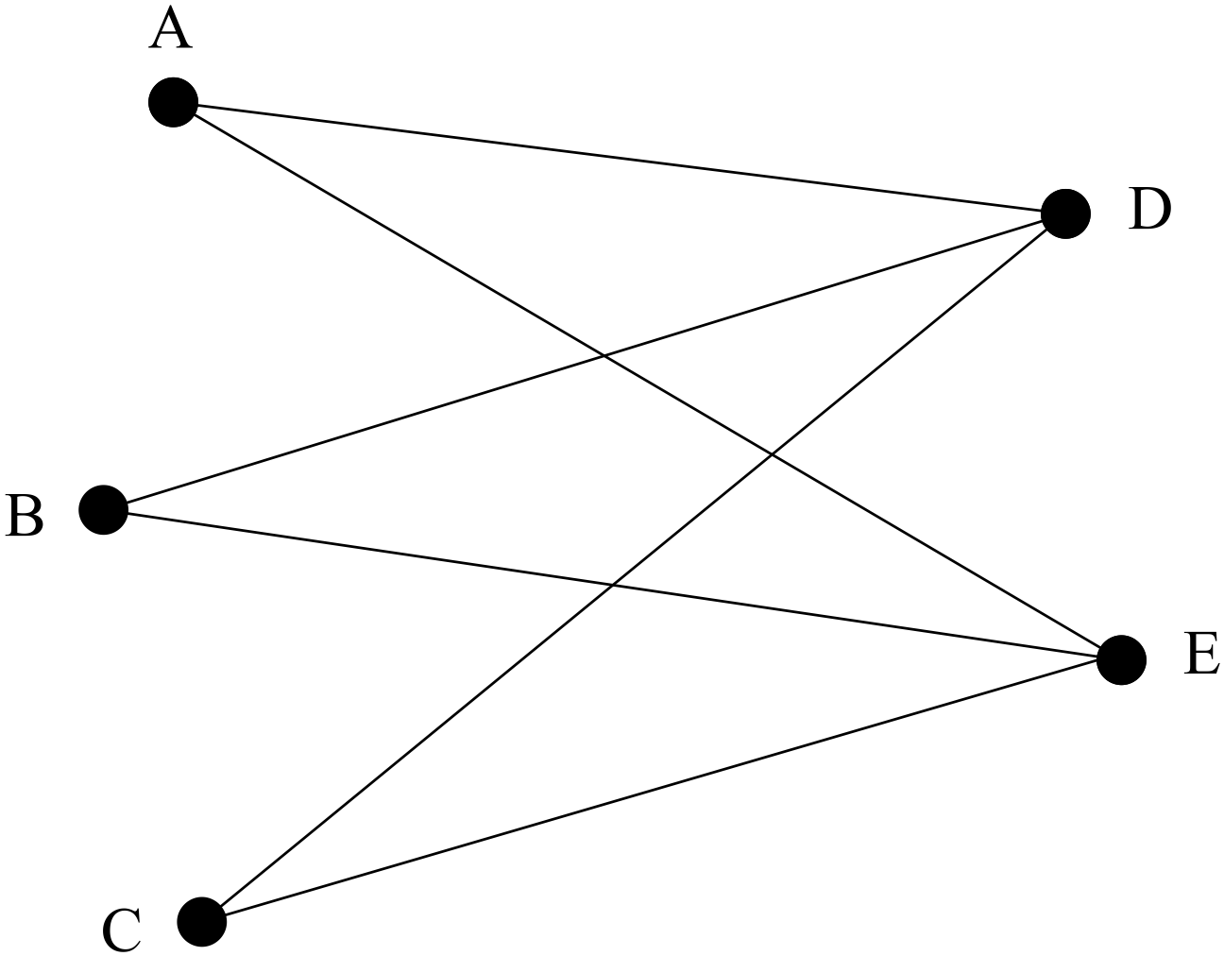

“Hamiltonian graph, Eulerian graph, bipartite graph, complete graph.” (2)

14. (4 marks)

Distances are in metres.
(a) List the shortest path between A and L. (2)

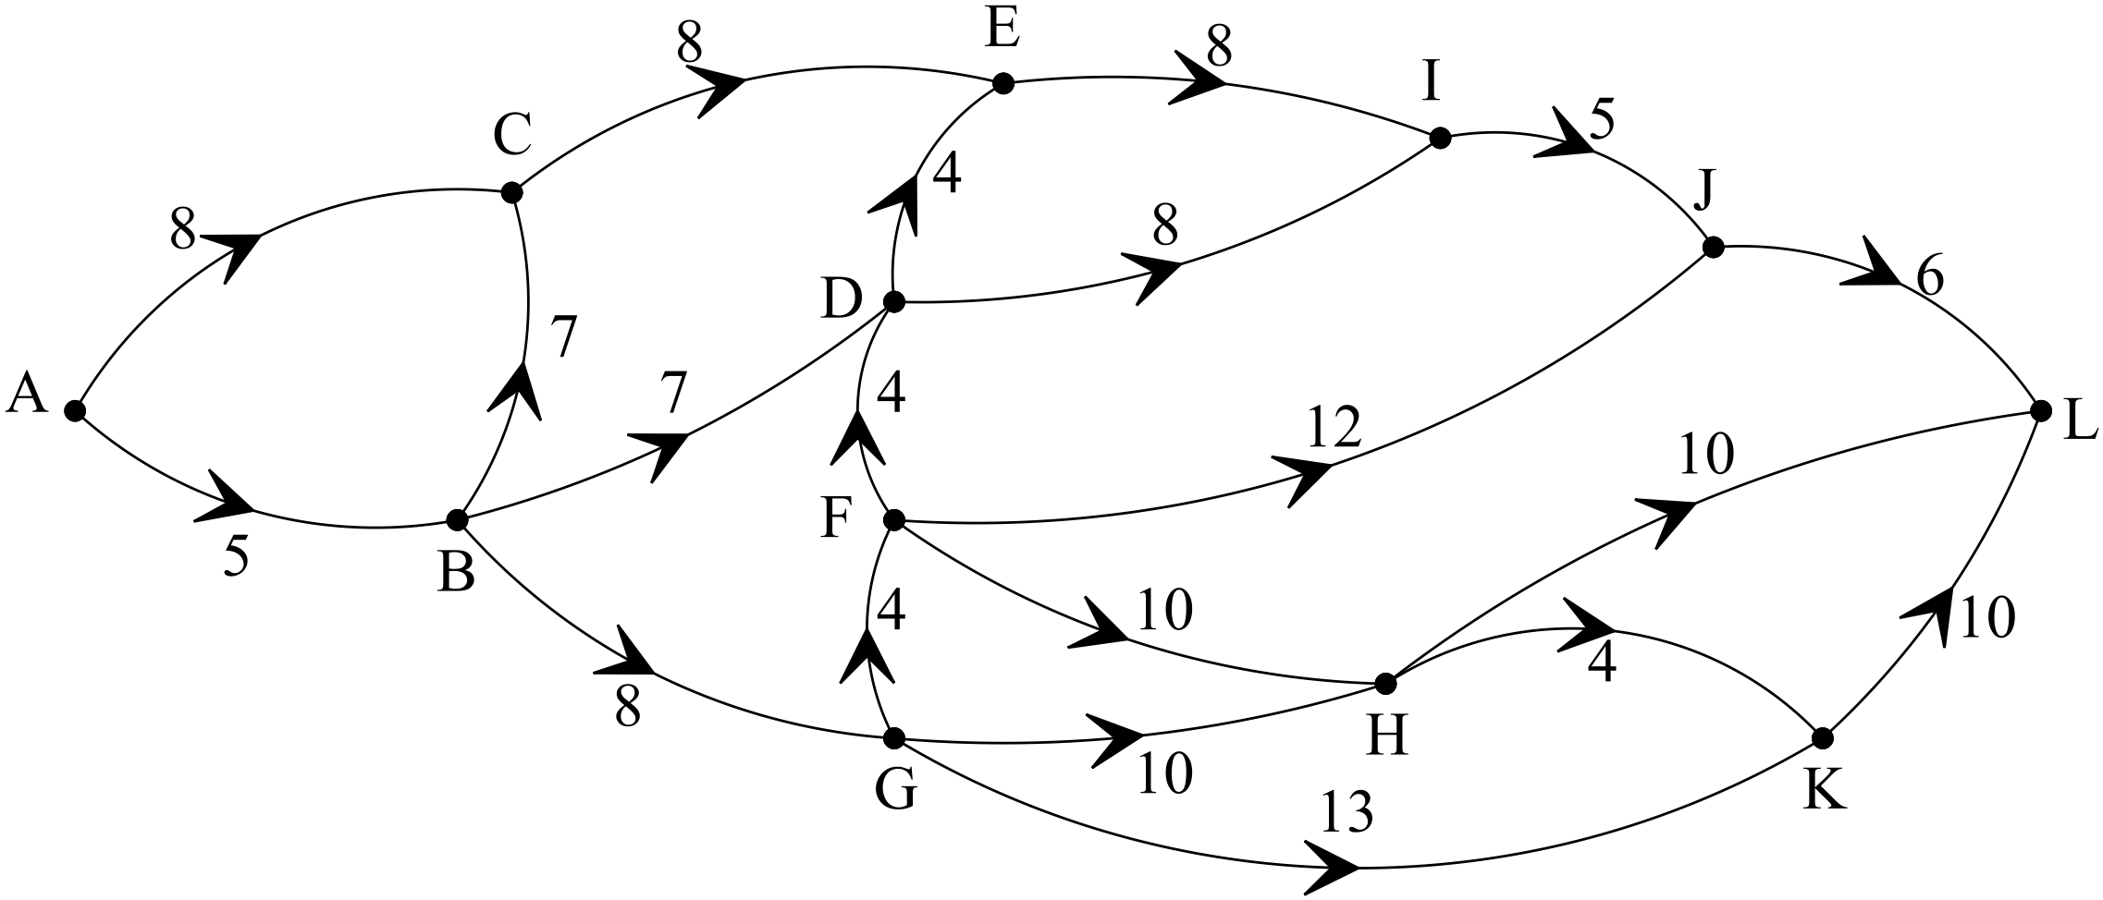

(b) IJ is flooded. How much longer is the shortest path without using IJ? (2)

15. (7 marks)

The number of employees at a large manufacturing company was thought to be growing at
5% per annum.
In 2015 the number of employees in the firm was exactly 400.

(a) Complete the following chart. (2)

Year | The expected number of employees
2015 | 400
2016
2017

(b) Write down a rule to predict the number of employees years after 2015. (2)

The manager checked the analysis and realised the young man doing it had neglected to take
into account the average of 10 people who retired from the firm each year (subtracted after the 5 % increase).

(c) Complete the chart with the manager’s adjustment. (2)

Year | The expected number of employees
2015 | 400
2016
2017

(d) Determine whether or not the number of employees is still growing each year. (1)

16. (11 marks)

The WA government has gone to the Premier’s meeting with the argument that WA should receive more of its GST back to spend in WA.

. The Estimated distribution of GST to the states:

2015-16 | Estimated Population | GST distribution to the states $million
NSW | 7 682 441 | $17 345
VIC | 6 001 823 | $12 755
QLD | 4 847 938 | $12 990
WA | 2 686 269 | $1 944
SA | 1 708 718 | $5 518
TAS | 517 161 | $2 236
ACT | 394 899 | $1 071
NT | 251 940 | $3 335
TOTAL | 24 091 189 | $57 194

http://www.budget.gov.au/2015-16/content/bp3/html/bp3_04_part_3.htm

(a) (i) Complete the two-way table below to shows the GST received per capita in
each state for 2015-16. NB per capita means per person. (4)

2015-16 | Estimated Population | GST distribution to the states in $million | GST received per capita per state
NSW | 7 682 441 | $17 345 | $2 258
VIC | 6 001 823 | $12 755 | $2 125
QLD | 4 847 938 | $12 990
WA | 2 686 269 | $1 944
SA | 1 708 718 | $5 518 | $3 229
TAS | 517 161 | $2 236
ACT | 394 899 | $1 071 | $2 712
NT | 251 940 | $3 335

(ii) Do you consider the distribution of the GST is fair to each state on a per capita
basis? (1)

(b) The table below shows the percentage of population in each state
and the percentage of GST received in each state.

2015-16 | Population | % of population | % of GST received
NSW | 7 682 441 | 32 | 30.9
VIC | 6 001 823 | 25 | 22.6
QLD | 4 847 938 | 20 | 21.5
WA | 2 686 269 | 11 | 4.9
SA | 1 708 718 | 7 | 9.1
TAS | 517 161 | 2 | 3.6
ACT | 394 899 | 2 | 2
NT | 251 940 | 1 | 5.4
Total | 24 091 189 | 100 | 100

(i) Explain how the % of the population per state is calculated. (2)

(ii) Explain how the % of GST received is calculated (2)

(iii) Explain the basic difference in the chart in (a) (i) and the chart in (b). (2)

17. (30 marks)
Consider the data in the below chart
2015-16 | % of Australian population | % of GST received
NSW | 32 | 30.9
VIC | 25 | 22.6
QLD | 20 | 21.5
WA | 11 | 4.9
SA | 7 | 9.1
TAS | 2 | 3.6
ACT | 2 | 2
NT | 1 | 5.4
Total | 100 | 100

(a) Identify the response variable and the explanatory variable. (2)

(b) Construct the scattergram on the set of axes below. Label teach axis. (4)

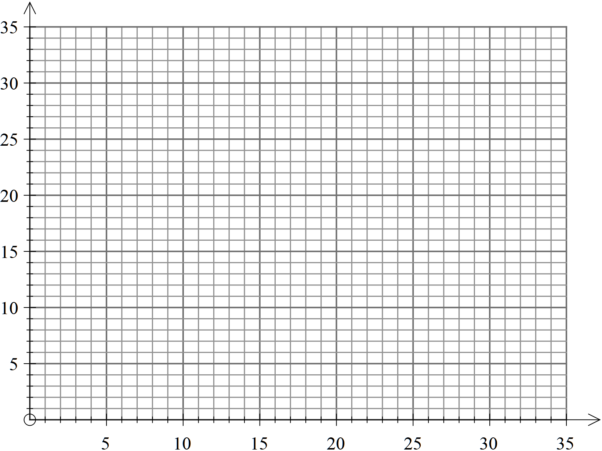
(c) Describe; the association between the response variable and the explanatory
variable in terms of positive or negative correlation, linear or non-linear and the
strength of the relationship. (3)

(d) Calculate the correlation coefficient. (2)

(e) Find the equation of the least-squares regression line. (3)

(f) Sketch the regression line on the scatterdiagram. (2)

(g) Explain the relationship between the sign of r and the gradient of the
regression line. (2)

(h) Predict the percentage of the GST WA should receive based on the population in WA as
a percentage of the Australian population. (2)

(i) By inspection of the data on the scatterdiagram in relation to the regression line,
explain whether or not a linear fit was appropriate for this data. (2)

(j) Determine the coefficient of variation and use it to comment on the strength of the
linear association in terms of the explained variation. (3)

(k) (i) Write up a summary of your results in a systematic and concise manner. (3)

(ii) Do the results support the conjecture that
“WA should have a fairer percentage of the total Australian GST.” (2)

END OF SECTION TWO

